**GHANA COMMUNICATION TECHNOLOGY UNIVERSITY**



**PROJECT WORK**

**QUAICOE MARTIN**

**2425405083**

**COURSE TITLE: MULTIMEDIA AND WEB DESIGN**

**COURSE CODE: IT 245**

**COURSE LEVEL: BIT L200 (EVENING)**

**DR EBENEZER AKAGLO**

**ELITE AUTOS ONLINE CAR SHOWROOM**

**Project Title: Elite Autos Online Car Showroom**

**Student Name: Martin Quaicoe**

**Course: Web Development / Systems Analysis**

**Lecturer: EBENEZER AKAGLO**

**Date: 30TH JANUARY, 2025**

# **Chapter 1: Introduction**

The rapid advancement of internet technologies has transformed how businesses operate and interact with customers. One such transformation is the use of online platforms to showcase products and services. The Elite Autos Online Car Showroom was developed to provide users with a simple, attractive, and user-friendly platform to view available cars, learn about specifications, and navigate through different sections of the website.

This project demonstrates the practical application of HTML and CSS in developing a static website while following standard web design principles. The website focuses on clarity, ease of navigation, and visual appeal.

## **Chapter 2: Project Background and Objectives**

**2.1 Background of the Project**

Traditional car dealerships rely heavily on physical visits, which may not always be convenient for customers. An online car showroom allows users to browse vehicles at any time, compare options, and gather information before making purchasing decisions. Elite Autos was created to simulate such an online showroom.

**2.2 Objectives of the Project**

The main objectives of this project are:

* To design and develop a functional online car showroom
* To apply HTML for structuring web content
* To apply CSS for styling and layout design
* To create multiple linked web pages
* To ensure easy navigation and readability

# **Chapter 3: Planning and Requirements Analysis**

### **3.1 Target Users**

The target users of the Elite Autos website include:

* Potential car buyers
* Car enthusiasts
* General users seeking car information

### 3.2 Functional Requirement

The website is expected to:

* Display a homepage with a sc section
* Provide a cars page listing available vehicles
* Allow navigation between pages
* Display images and specifications of cars
* Provide contact information

### 3.3 Non-Functional Requirements

* The website should be visually appealing
* Pages should load quickly
* The layout should be simple and clear
* The website should be easy to use

### 3.4 Sitemap

**Figure 3.1:** Sitemap of the Elite Autos website showing links between Home, Cars, About, and Contact pages.

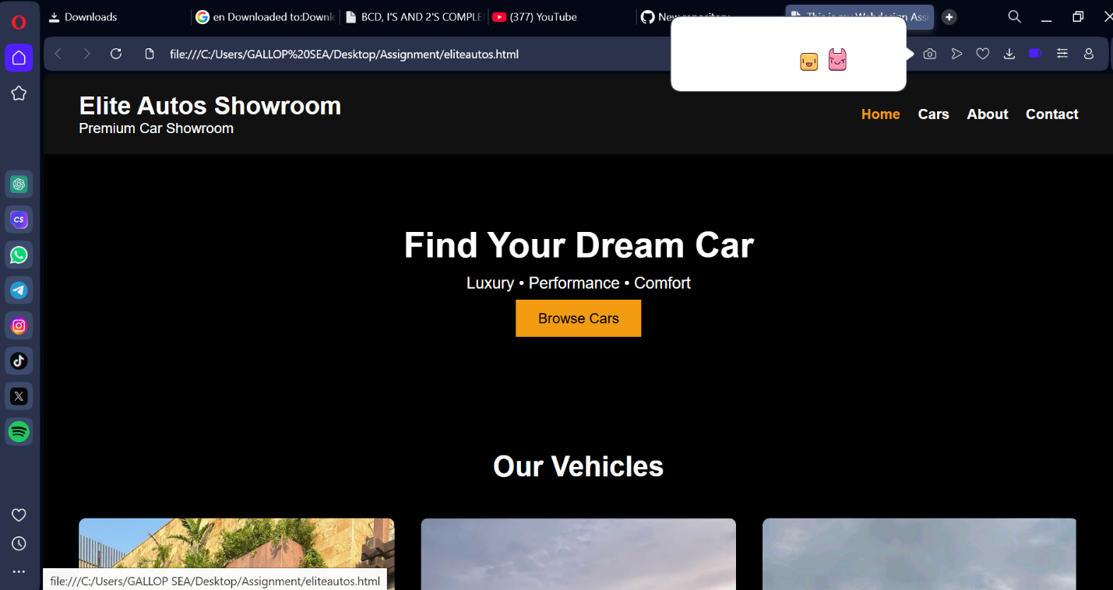

As shown in Figure 3.1, the homepage serves as the central navigation point

linking to all other pages.

# **Chapter 4: Tools and Technologies Used**

### 4.1 HTML

HTML (HyperText Markup Language) was used to structure the content of the website. Elements such as headers, sections, navigation menus, images, and links were created using HTML tags.

### 4.2 CSS

CSS (Cascading Style Sheets) was used to style the website. CSS controlled colors, fonts, layouts, spacing, backgrounds, and responsiveness.

### 4.3 Development Tools

* Visual Studio Code (VS Code)
* Web browsers (Chrome, Firefox)
* Local file system for image storage

# **Chapter 5: Website Design**

### 5.1 Layout Design

The website follows a clean and structured layout. A navigation bar is placed at the top of each page to ensure consistent navigation. Sections are clearly separated using containers and spacing.

### 5.2 Color Scheme and Typography

The website uses a modern color scheme with contrasting text colors to ensure readability. Times New Roman is used for documentation, while simple sans-serif fonts are used on the website.

### 5.3 Hero Section Design

The sc section contains a background dark color of a car and a call to action button. This section creates a strong first impression for users.

**Figure 5.1:** Homepage hero section design.

As shown in Figure 5.1, the hero section includes a background color and a "Browse Cars" button. 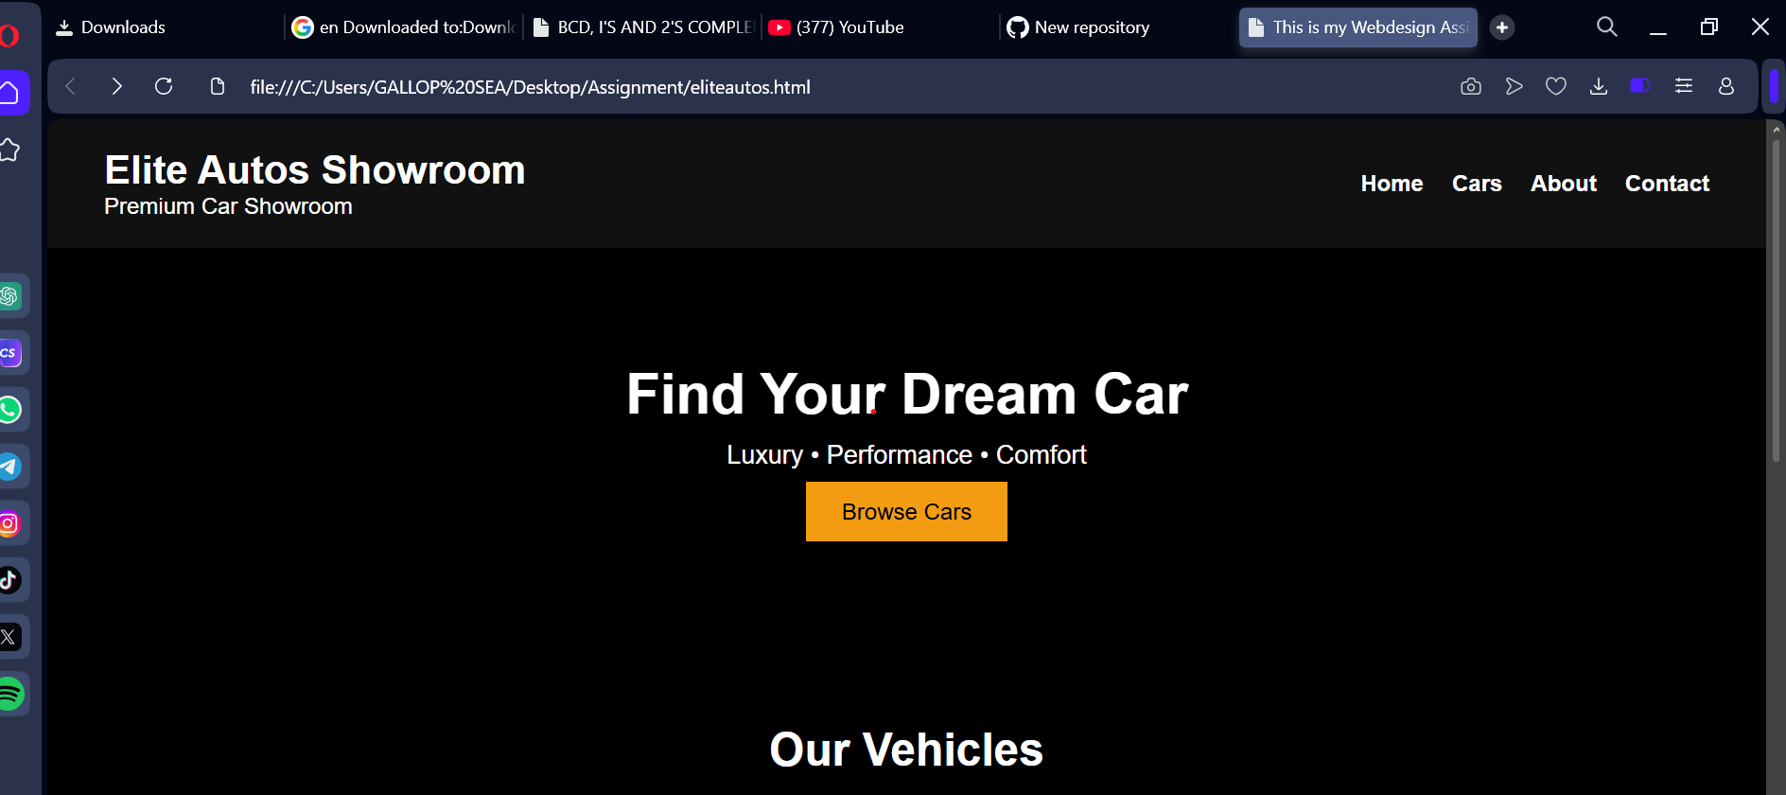

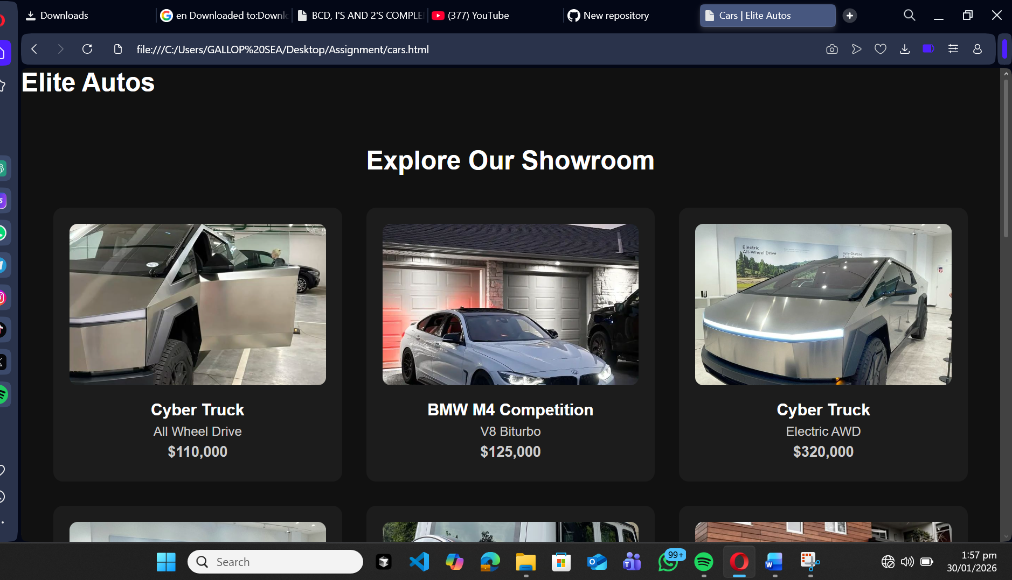

# **Chapter 6: Implementation (HTML & CSS)**

### 6.1 HTML Structure

Each webpage was structured using semantic HTML elements such as header, nav, section, and footer. Div elements with class attributes were used to group content and apply CSS styling.

### **6.2 CSS Styling**

CSS was used to control layout and design. Background images, padding, margins, hover effects, and containers were applied to enhance visual appeal.

**Figure 6.1:** Screenshot of CSS file used to style the website.

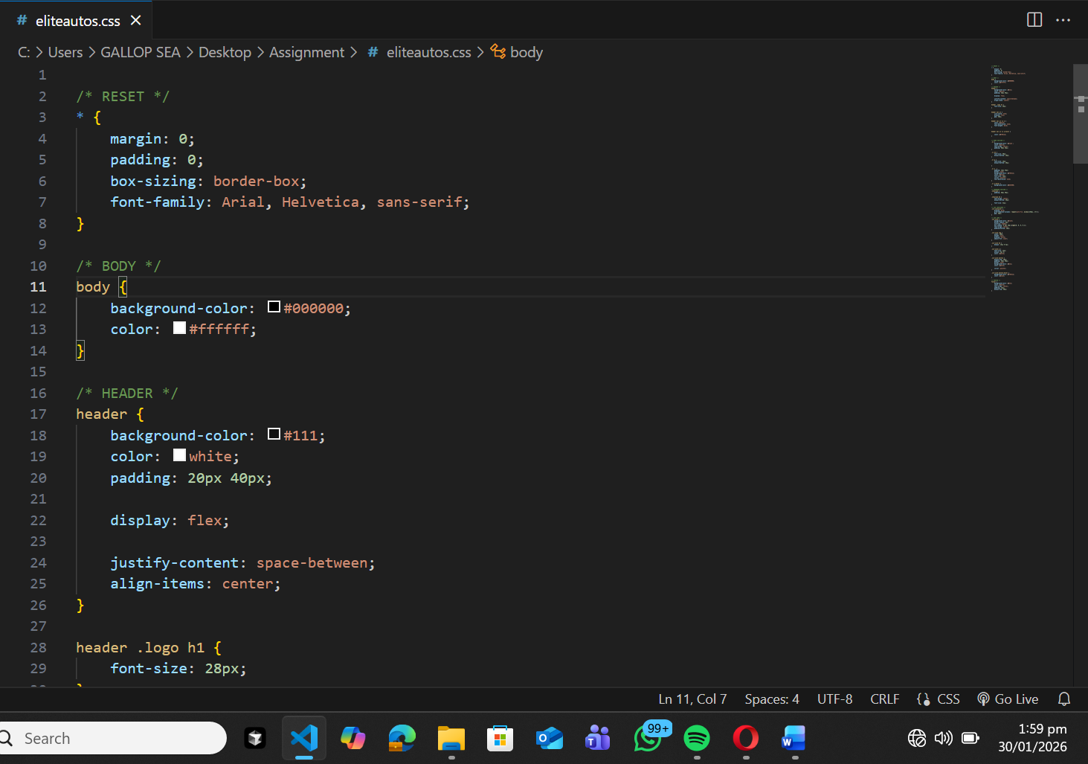

As shown in Figure 6.1, CSS rules were used to style navigation menus, hero sections, and content containers.

# **Chapter 7: Description of Website Pages**

### 7.1 Home Page

The home page introduces the website and contains a hero section, navigation menu, and featured cars.

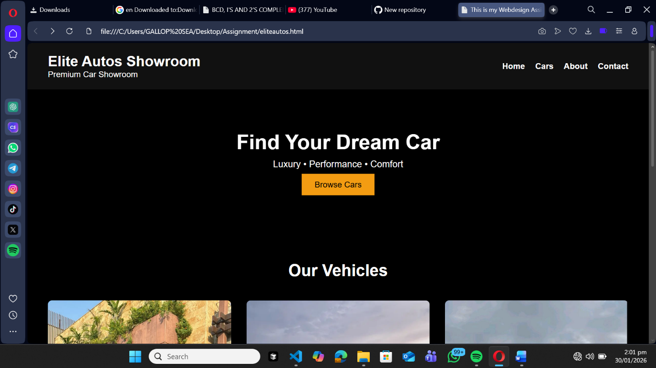

**7.2 Cars Page**

The cars page displays available vehicles in containers, each showing an image, specifications, and a view details button.

**Figure 7.2:** Cars listing page.

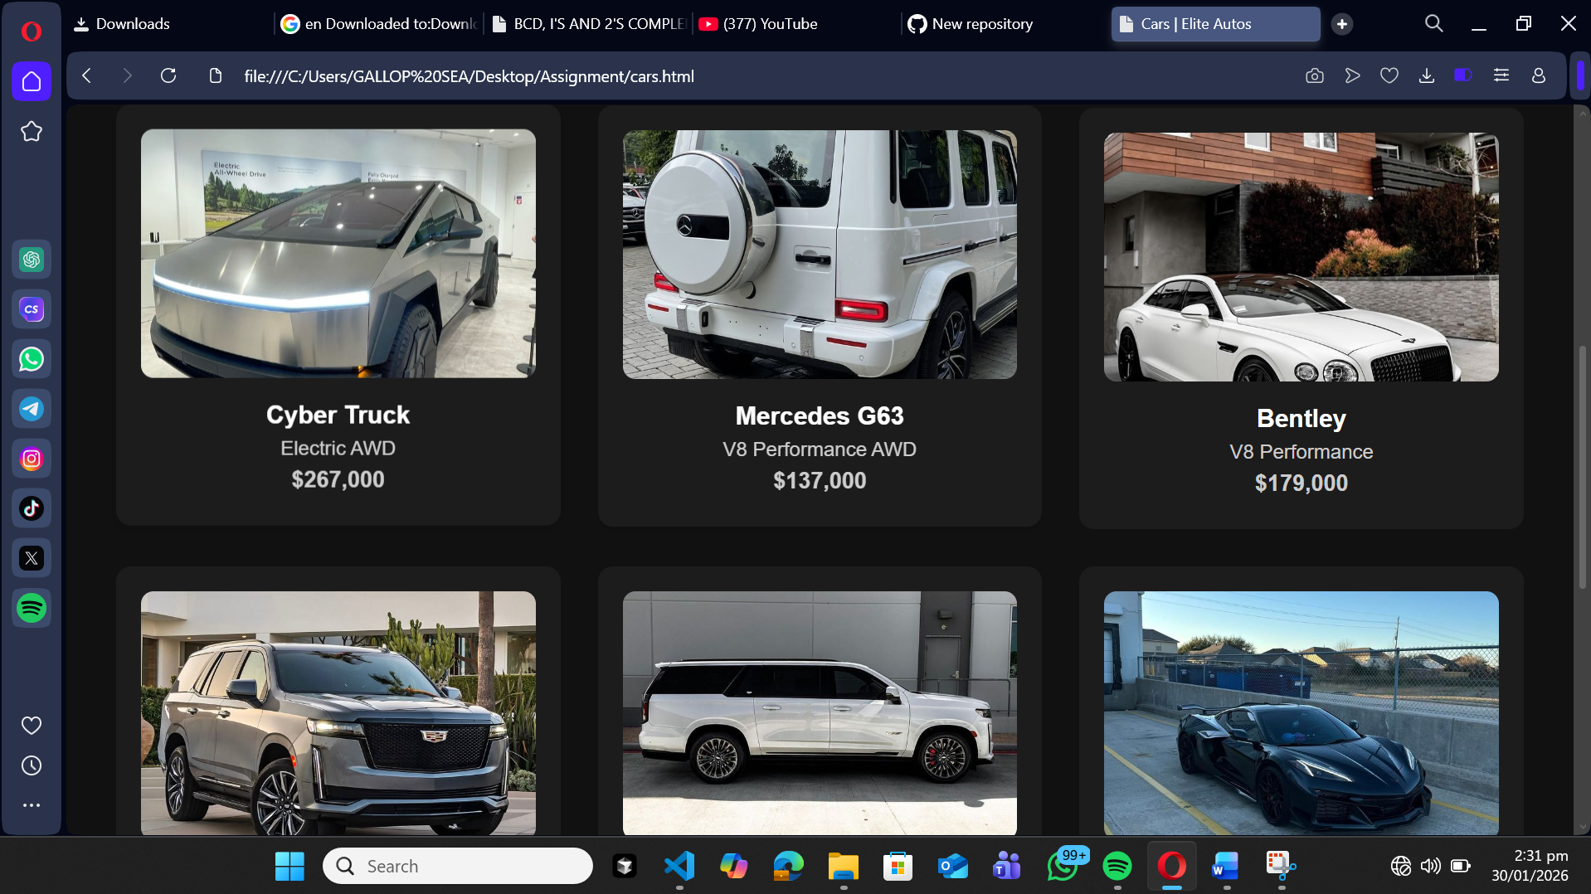

### 7.3 About Page

The about page provides information about Elite Autos and the purpose of the website.

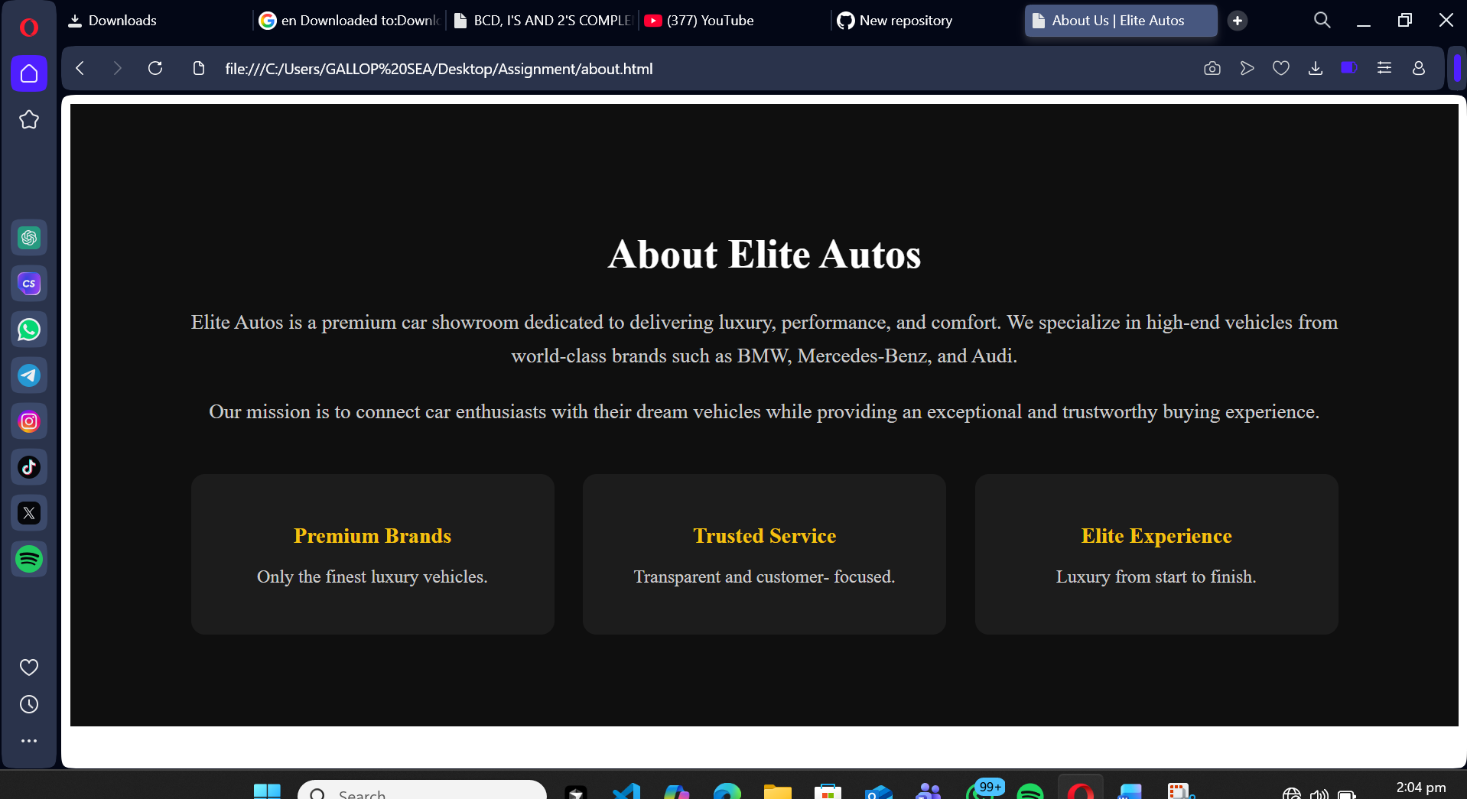

### 7.4 Contact Page

The contact page allows users to view contact details and reach out for inquiries.

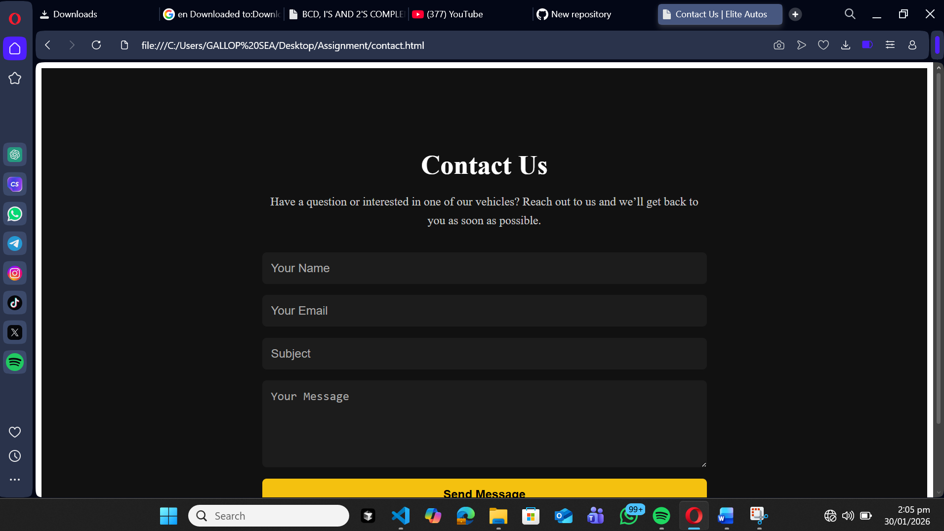

### Chapter 8: Testing and Validation

The website was tested to ensure:

* All links function correctly
* Images display properly
* Pages load without errors
* Navigation is consistent across pages

Different browsers were used to test compatibility.

# **Chapter 9: Challenges Encountered and Solutions**

### 9.1 Linking CSS to HTML

One challenge encountered was linking the CSS file correctly. This was solved by ensuring the correct file path and file extension were used.

### 9.2 Image Display Issues

Images initially failed to display due to incorrect file paths. This was resolved by organizing images into folders and correcting paths in the code.

# **Chapter 10: Conclusion and Future Improvements**

The Elite Autos Online Car Showroom project successfully demonstrates the use of HTML and CSS in building a functional website. The project met its objectives by

providing a clean layout, easy navigation, and visually appealing design.

Future improvements may include:

* Adding JavaScript for interactivity
* Making the website fully responsive
* Integrating a backend for real-time data